* + 1. **The guidance below serves to assist in the identification of objects that may need securing and in the most adequate methods for that**

* + 1. **The recommended methods are presented in a universally applicable and flexible way**
    2. **It is recommended that crew convert this guidance into a form suiting the particular ship and its available securing equipment**
    3. **A non-exhaustive list of examples of typical heavy objects per onboard departments:** 
       1. objects that should be permanently secured:
* Hotel department - heavy plant pots, sculptures, TVs, cash machines, laundry equipment, slot machines, game machines such as in teen recreation areas
* Shops department - display stands and racks
* Beauty Salon/Spa/Gymnasium department - treatment tables, heavy standalone product displays, treadmills, exercise weight racks, weight lifting machines, display stands and racks
* Entertainment department - pianos, lounge speakers, back-stage scenery equipment, platforms
  + - 1. objects that should be secured at all times when not in use:
* Food & Beverage department - store trolleys, baggage cages, plate warmer trolleys, forklift trucks and compressed gas bottles
* Housekeeping/Hotel Department – steward trolleys, lecterns
* Deck department - paint rafts, gangways, deck trash containers, heavy chemicals, paint containers, spare extinguishers
* Security and Medical departments - X-ray machines
* Technical department - cylinder heads, pistons, charge air coolers, gas bottles, heavy chemical containers, heavy A/C coils /equipment, heavy fan impellers, large spare valves, lube oil drums, spare el . motors
  + - 1. objects not otherwise secured that should be secured for heavy weather
* Loose objects on display
* Temporary decorations
* Items brought aboard temporarily as part of shows
* Materials/equipment onboard as part of repairs/refurbishment
  + 1. **Specific heavy objects that have been identified by the Company that require particular attention**
       1. Power pack containers:
* Securing to be calculated as compliant with the CSS Code (may be subject to PSC inspection) and the securing devices certificated
* Use of software and relevant printouts such as BV Lash or DNV Lashcon is recommended
* Recommended securing methods and devices for containers:

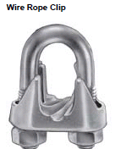 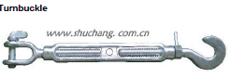

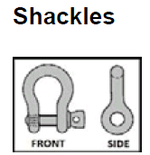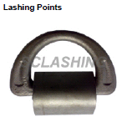

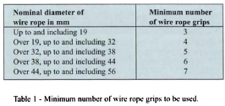

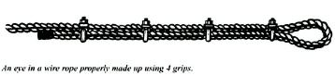

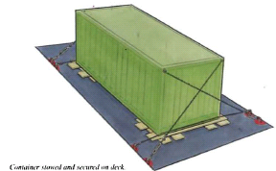

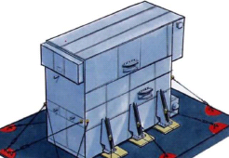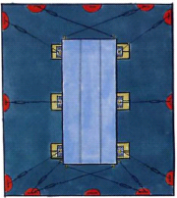

* + - 1. Spare anchor(s)
    1. **Securing methods and devices:** 
       1. Consideration should be given to:
* the strength and appropriateness of each point of attachment to which the objects are secured (the weakest component in an assembly will be governing):
  + "Maximum securing load" (MSL) is a term used to define the load capacity
  + (typically in kN, **where 1kN is approx. 102 kg** ) for a device used to secure objects to a ship.

MSL is a proportion of the breaking strength as follows:

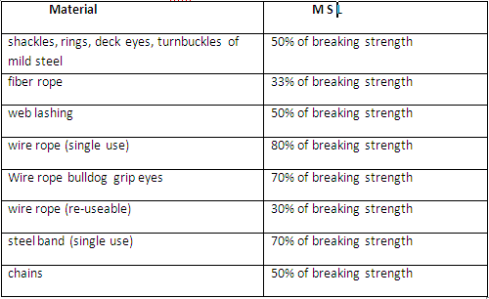

* + "Safe Working Load" (SWL) may be substituted for MSL for securing purposes, provided this is equal to or exceeds the strength defined by MSL
* The location of the item onboard as highest accelerations from ship’s motion occur at the ship’s ends: fore, aft and highest decks
* Sliding or Tipping
  + Items which have a low centre of gravity and a large base are likely to slide before they tip over

* + Friction forces affect sliding due to nature of materials in contact:

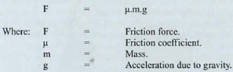

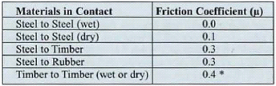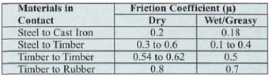

Hence surfaces should be lined up with materials with high friction coefficients and/or low level securing to prevent sliding

* + Items which have a high centre of gravity and a small base are likely to tip over. Such items in addition to other securing lashings should be fitted with high level lashings and/or propped by shoring at its higher parts
  + The local strength of the deck to ensure no structural damage will occur due to heavier weights
    - 1. Rule of Thumb:
* **The total of the MSL values of the securing devices on each side of a unit / object (port as well as starboard) should equal the weight of the object**
* Transverse securing angles to the deck should not be greater than 60° and it is important that adequate friction is provided by the use of suitable material. Additional securing at angles of greater than 60° may be desirable to prevent tipping but are not to be counted in the number of securing lashings under the rule-of-thumb
* Some of the securing should have fore-aft component as well as an athwartship component (securing that leads directly fore or aft and have no athwartship component should not be included in the above MSL calculation)
* Example:
  + *Weight of an object (ie heavy container on deck) to be secured = 20’200 kg = 20.2 tonnes*
  + *Total required MSL on EACH side ~ 198.1 kN*

*VS.*

* + *WEAKEST / governing of the combined arrangement of Securing devices* 
    - *bulldog grip eye 18mm wire with 13.2 tonnes breaking strength (MLS at 70% = 9.24 tonnes)*
    - *large D shackle marked with SWL 20 tonne (MSL at 50% = 10.0 tonnes)*
    - *turnbuckles 500mm, breaking strength 19.0 tonnes (MSL at 50% = 9.5 tonnes)*
    - *D rings fittings rated at 35 tonnes (MLS at 50% = 17.5 tonnes)*
  + *-> weakest MSLis of bulldog grip eye wire of 9.24 tonnes or 90.6 kN*
  + *2 (two) securing arrangements / devices on each side = 18.48 tonnes or 181.2 kN*

*?*

* + *Conclusion = 181.2 kN securing < required MSL 198.1 kN -> insufficient lashing/securing*
  + *Requirement = minimum 3 (three) devices of MSL 9.24 tonnes to give 27.72 tonnes or 271.8 kN on each side > 198.1 kN*
    - 1. **Examples of (combinations of other) securing methods and devices with illustrations:**
* A – Latch type gate hook and eye bracket mounted on bulkhead or vertical surface:

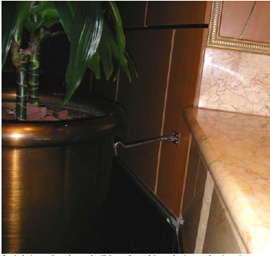

* B – Link style chain and eye type brackets mounted on bulkhead or vertical surface:

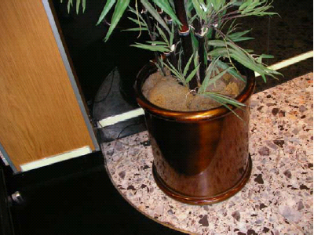

* C – Bolts through base into tapped holes in welded Deck Pad or Deck anchor device:

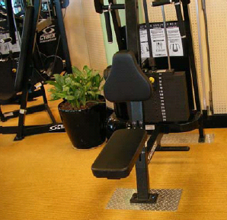 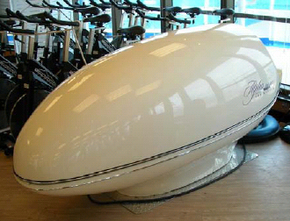

* D - Ratchet strap and eye brackets mounted onto bulkhead or vertical surface:

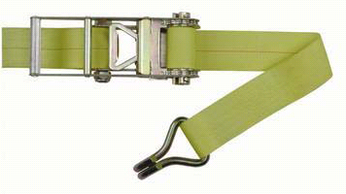 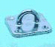

* E – “U” shaped steel bracket round object bolted to bracket on bulkhead or vertical surface or pillar:

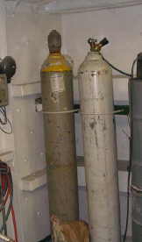 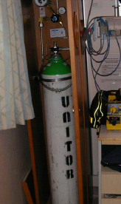

* F – Brackets, shackles, wire strops and turnbuckles:

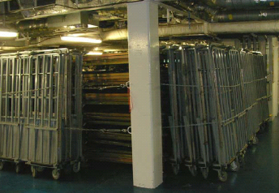

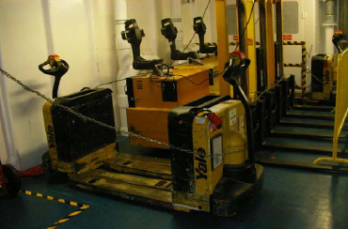

* G – Angle bar welded to structure with studs, bolts and or brackets:

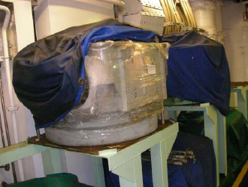

* H – Steel frame mounted to deck and bulkhead with suitable retaining bracket:

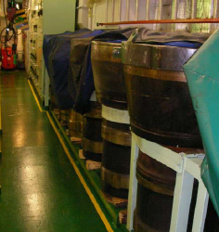 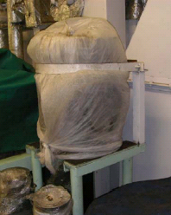

* I – Sand filled leather pouches:

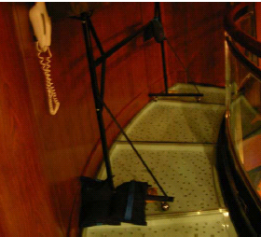

* J – Deck mounted bases suitable for object legs secured into the deck with bolts:

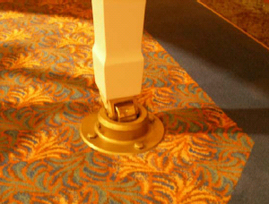 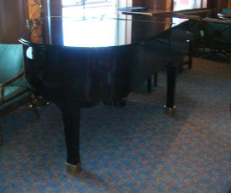

* K – Steel bulkhead mounted “U” shaped hooks and ratchet straps:

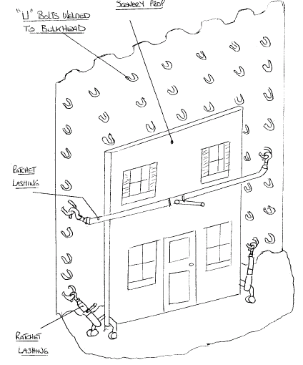

* L – Angle bar frame with securing points for bolts:

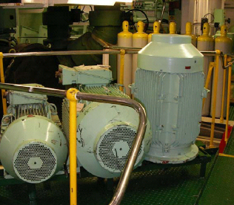

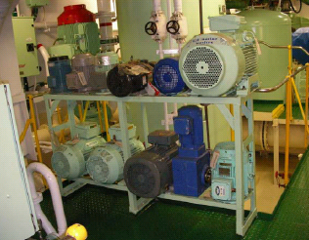

* M – Bracket mounted on bulkhead with wire and spring clip and friction pad under object:

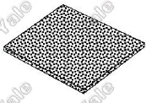 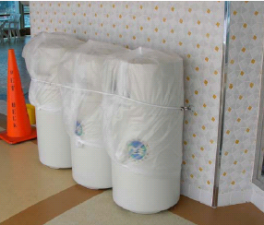

* N – Deck mounted on plinth with securing brackets on front bolted to plinth:

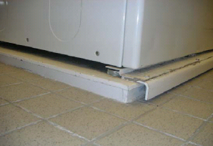

* O- Bracket on object with associated bracket on bulkhead and pin or bolt through brackets:

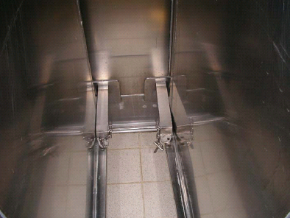

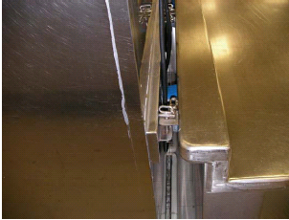

* P - Rope /Wire Rope– Secured to object and adjacent suitable securing surface

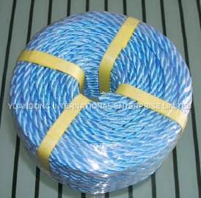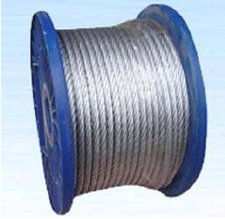

* Q - Permanent securing such as bolting/bracketing to bulkhead:

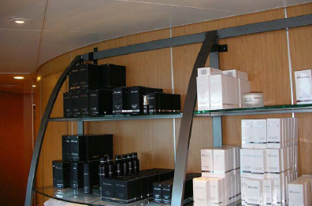

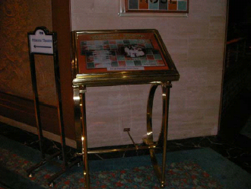

* R– Steel bracket on object secured to deck with bolts

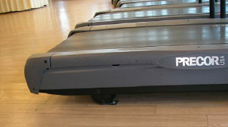

* S – Spring loaded door mounted latch with deck mounted steel pipe for latch to engage when door in “open” and “closed” position:

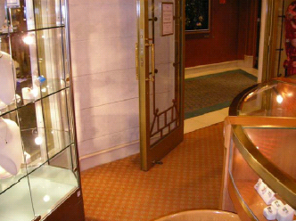

* T – Contained in metal rack type shelving system:

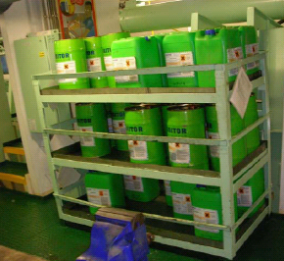

* U– Steel frame with studs and butterfly/wing nut:

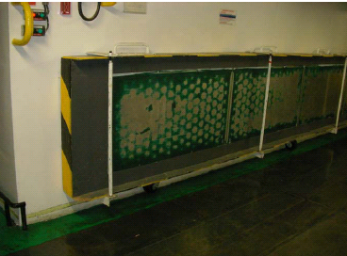

* V– Plate style base fitted to object and upturned end secured to toe kick or similar surface:

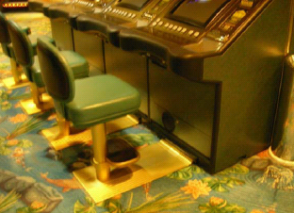

* X – Suction cup and bracket/ratchet strap/chain, etc

